Step 1:
https://sis.wayne.edu/mlis
I chose this page for two main reasons. First, it was the page I used when actively looking for a masters program, in which I ultimately chose Wayne University. Second, it has the requirements for this assignment. On a more personal level, I enjoy the set up. I like the photograph is stylized as a circle and placed next to a direct quote. The page has flair without it being unprofessional. I also like that it has clearly marked sections. When discerning what school to go to, this set up was very helpful when acquiring information.
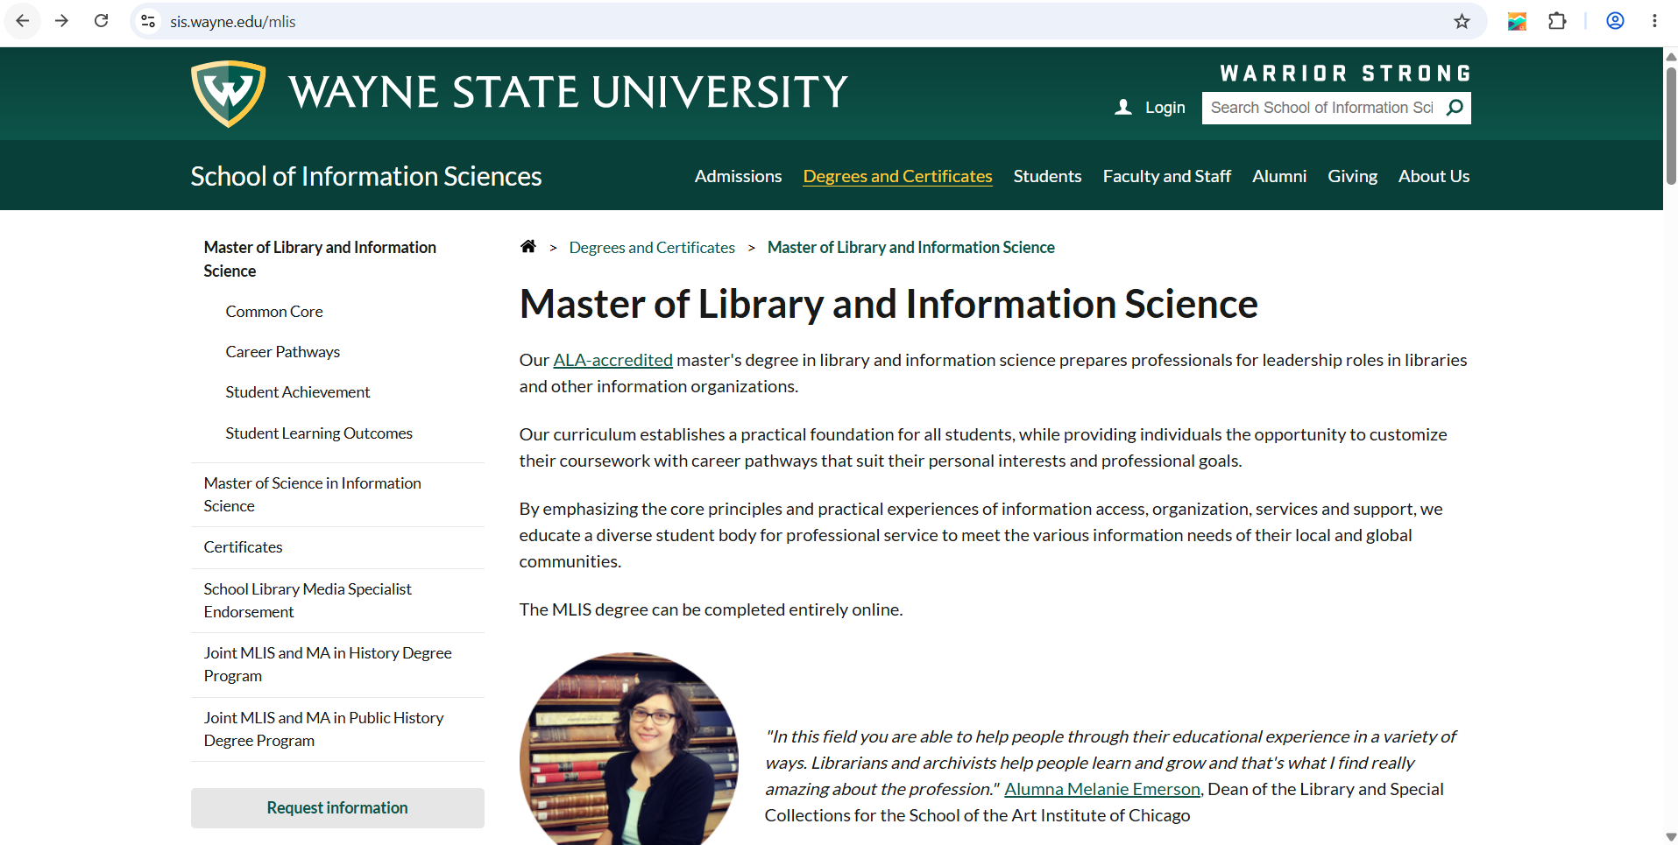

Step 2:
Here is the header: <header>
This heads the page. It contains pertinent access to relevant topics pertaining to the page, as well as main navigation back to the home page of Wayne State University.
Which contains the site navigation: <nav>
This column is the <main> element:
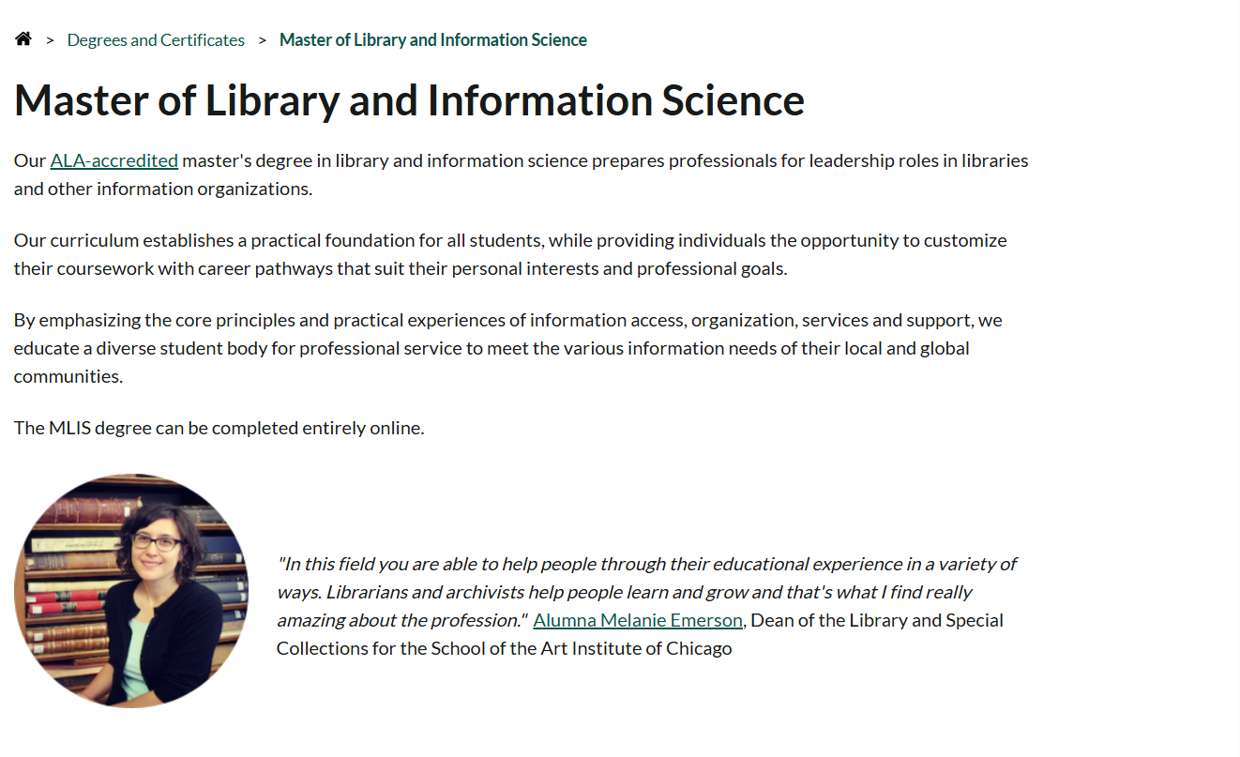
That includes an <ul> un ordered list:
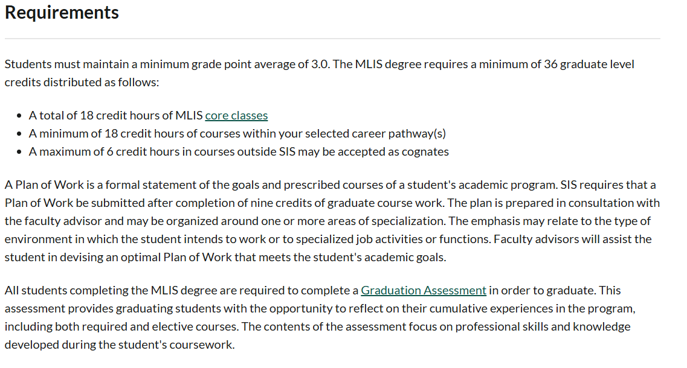
But there is another <ul> found on the side bar, as marked up in its html:
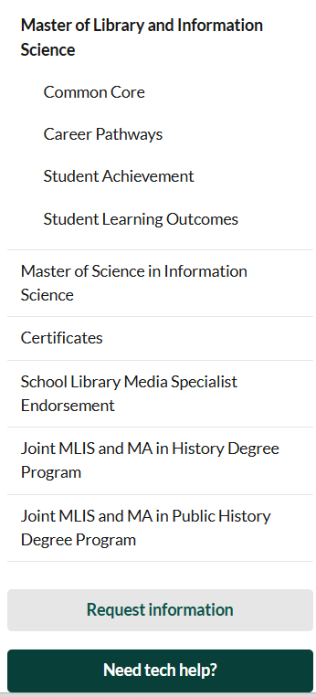
The footer <footer> is used to provide links to social media:
It appears a lot of footers are used for social media. Even with pre-designed webpages like squarespace, or any other blog space. It allows easy access to the school’s relevant links beyond the school website itself. It wouldn’t make sense to place this in the navigation bar, for example, because that is for navigating the wayne.edu site in general. The page is not so long as to warrant a “back to top” for the footer, or even a “home page” link in the footer, as there is already a button in the navigation.

Step 3:
“Wayne State University” is Header One, “School of Information Sciences” Header Two and the navigation links possibly header 3.
As you can see above, we have <h1> the first header. This is self evident when compared to the <h2> second header as shown below:

There doesn’t appear to be a <h3> third header in the traditional sense, however, if one views the “Career Pathways” section, it appears the different sections use <h3>

Step 4
Data in this table presents different topics pertaining to MLIS. This list is <ul> because it isn’t ordered specifically and it doesn’t have any descriptions associated with them. These are linked.

There is an unordered list in the <main> section, which would be <ul>


Step 5
Majority of links on this page are internal such as the “core classes” or “Graduation Assessment” links as shown above.
These links below go to social media and thus are external as they are not wayne.org

Step 6
This looks like a table but it isn’t. it is a <div> element


